AIT 524: Weekly Assignment 03
Tanmoy Chowdhury
George Mason University

Author Note
This task is being submitted as an assignment task 03 for the course ‘Database Management Essential’ offered in Sprig 2018. It is pretty similar with the assignment 02. But, the ER diagram has been changed based on the week 03 class lectures as I have learned cardinality, optionality, weak and strong relationship from that class. I applied those in the diagram. For any kind of inquiry, feel free to contact at tchowdh6@masonlive.gmu.edu.

Online Drill
Soccer is a very popular game over the world. We know soccer is not only a 90 minutes game. It needs lot of dedication and technique by individual and by teamwork. Though there is lot of coaching stuff but in case of online resources the material is not sufficient. This is a website for coaching soccer. This website will contain the motion pictures on drill in different categories. It would contain subscriber at different stages. There would be specific drill set based on the user’s categories.

Necessity of database for this online-drill company
This website contains subscriber with different skill set. A player can register for different type as like Goal-keeper, defense, Stricker. Every type has three skill levels as like beginner, intermediate and expert. Moreover, it has lot of motion pictures which are categorized in different panels. It would become messy if it is not organized in a database. That is why, this online company needs a database.

Business Requirements:
The goal of this website is to provide training for the players. A player can hesitate at the very beginning level about his playing position. As like, a player can be interested in either goal-keeper or defense or striker. Again, a player can be interested in all three types. Every type consists of three different level as like beginner, intermediate, and expert level. For better understanding the scenario, think about a player ‘John’ of age 14. This player can be enrolled as Goal-keeper Beginner Level, Defense Expert Level and Striker Intermediate level simultaneously.
For every category of playing, there would be drill set for dribbling, passing and shooting. For instance, John has already enrolled for Goal-Keeper Beginner Level. This category can be consisting of 2 dribbling drills, 1 passing drills and 5 shooting drills.
In a summery, a player can enroll among 9 categories (Goal-Keeper, Defense, Stricker with Beginner, Intermediate, Expert level) as much as he wants. Every category consists of drill from 3 sets (Dribbling, Passing, Shooting). A drill can be only one type either dribbling or passing or shooting. One drill cannot be part of two different sets.
Based on the business scenario, this website would contain many entities. I hope to come up with a perfect set of entities though out this course by brainstorming more and more. As an initiative step, I have figured out four entities. They are Player, Category, Drill and PlayerCatDrill. At first I am pointing the business rules and then the description of entities and relationship will be stated.
Business Rules:
- Each player can enroll in one or more categories.
- Each player can practice one or more drills.
- One drills can be practiced by many players
- One drill can be enrolled in one or more categories
The explanation I have described already at the beginning of this paragraph ‘Business Requirements’.
Entities of the system
In previous paragraphs I have discussed the business scenario and the cause of choosing the entities. If we want to have a detail version of the entities, then we can end-up as like following:
PLAYER:
This entity is the very beginning step of this web for user-interaction. A user will open his account. Every player will possess an unique id. He can choose one or more category id among those 9 categories. He will not be allowed to choose other than those.
- player_id: A unique id choose by user. It would be VARCHAR. Maximum 10 character will be allowed.
- email: Mandatory attribute as it is necessary to contact with player. Type: VHARCHAR.
- age: Number type

CATEGORY:
Every category would have id (1~9). For more detail description it would contain the attribute player_type and player_level. Moreover, it would also contain player_id and drill_id.
- category_id: (1~9) (Category Chart has been attached here)
- player_type: (Goalkeeper/Defense/Stricker)
- player_level: (Beginner/Intermediate/Expert)

1 | Goalkeeper-Beginner
2 | Goalkeeper-Intermediate
3 | Goalkeeper-Expert
4 | Defense-Beginner
5 | Defense -Intermediate
6 | Defense -Expert
7 | Striker-Beginner
8 | Striker -Intermediate
9 | Striker -Expert
Table 01: Category table
DRILL:
For drill, it should have unique id and type. It will also have duration of every drill in seconds.
- drill_id: VARCHAR (10)
- drill_type: (Dribbling/Passing/Shooting)
- drill_duration: number

PLAYERCATDRILL:
It is very difficult to implement many-to-many relationship in case of relational database. So, for making the relations among those three entities this PLAYCATDRILL entity is necessary. It has three attributes whose is not only as primary key but also as foreign key.
- player_id: VARCHAR
- category_id: (1~9)
- drill_id: VARCHAR

Relationship
I would like to depict the relationship in a table with evaluation.
Entity 1 | Entity 2 | Relationship | Cause
PLAYER | CATEGORY | Many-to-Many | A player can be enrolled in many categories again one category can contain many players
PLAYER | DRILL | Many-to-Many, Weak | A player can practice many drills and one drill can contain many players.  It is weak relationship because, these two entities do not contain any parent key components among them. They are not existence-dependent on each other.
DRILL | CATEGORY | Many-to-Many, Weak | Every category is built with drill set of many drills. Similarly, every drill can be part of many categories.  It is weak relationship because, these two entities do not contain any parent key components among them. They are not existence-dependent on each other.
PLAYER/CATEGORY/DRILL | PLAYERCATDRILL | One-to-Many, Strong | One instance from any of these three entities (PLAYER/CATEGORY/DRILL) is related to many instances of PLAYCATDRILL entity.  It is strong relationship because, PLAYER, CATEGORY OR DRILL contains primary key component from PLAYERCATDRILL. PLAYERCATDRILL has composite primary key. This entity is dependent on PLAYER, CATEGORY AND DRILL. So, it is a strong relationship.
Table 02: Entity Relationship
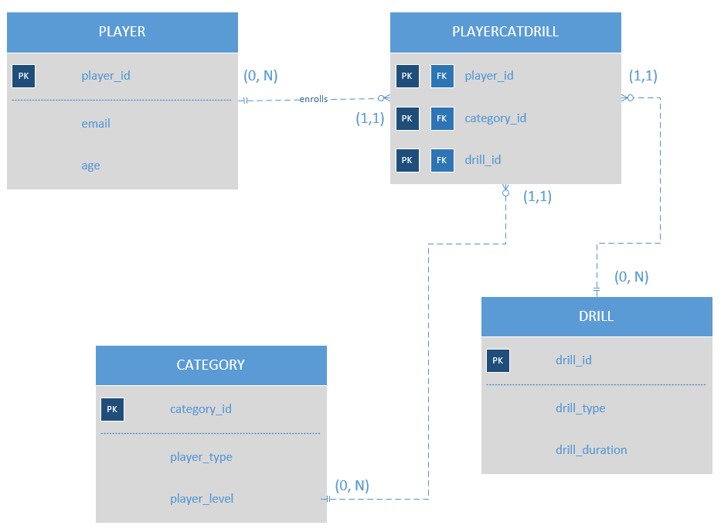
Figure 01: Entity Relationship Diagram

References
Elmasri, R., Navathe, S. B. (2016). Database system concepts and architecture in M. J. Horton, Fundamentals of Database Systems (7th ed., pp 31-56) : Pearson.

